Windows Server 2022 Active Directory Deployment

Overview
This project documents the deployment of a new Domain Controller in virtualized environment. The goal was to establish a foundational identity infrastructure using Active Directory Domain Services (ADDS) and (DNS).

Technical Stack
- Hypervisor : VMware Workstation
- OS : Window Server 2022
- Network : Static IP Configuration ( Subnet : 192.168.10.0/24)
- Roles : Domain Controller (DC), DNS Server

Implementation Steps

Step1 : Network Configuration
The server was configured with a Static IP (`192.168.10.2`) to ensure reliable reachability for domain clients.
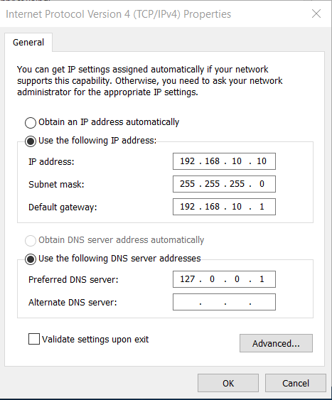

Step 2: Role Installation
Installed the Active Directory Domain Services (AD DS)role via the Server Manager wizard.
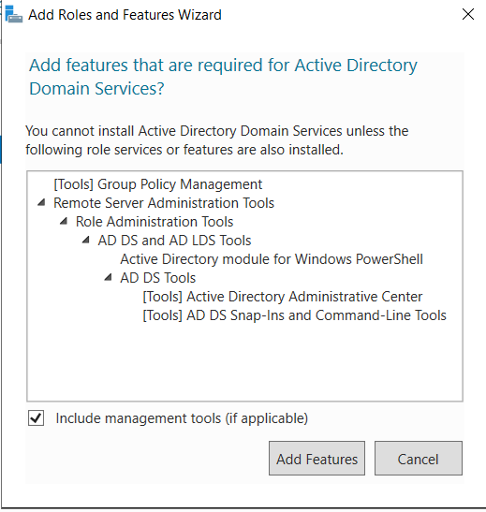

Step 3: Domain Promotion (New Forest)
Promoted the server to a Domain Controller. I created a new forest root domain named corp.local.
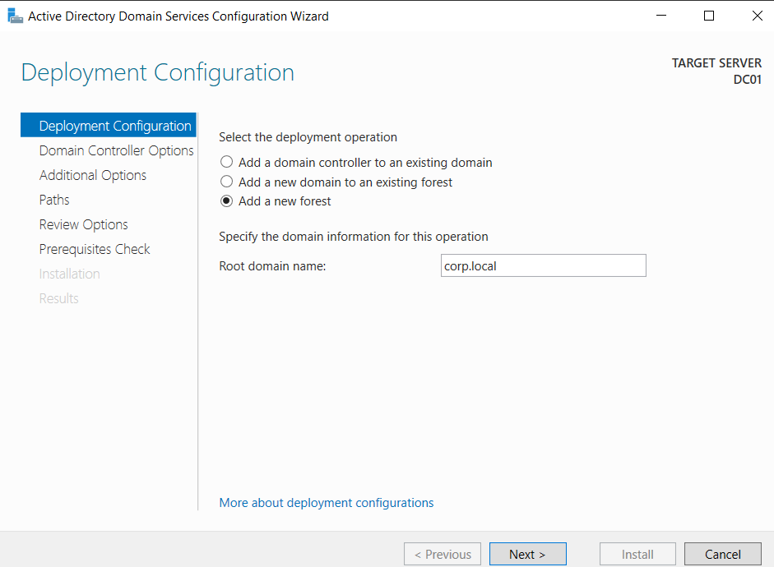

Step 4: NetBIOS Configuration
Verified the NetBIOS domain name to ensure compatibility with older legacy systems on the network.
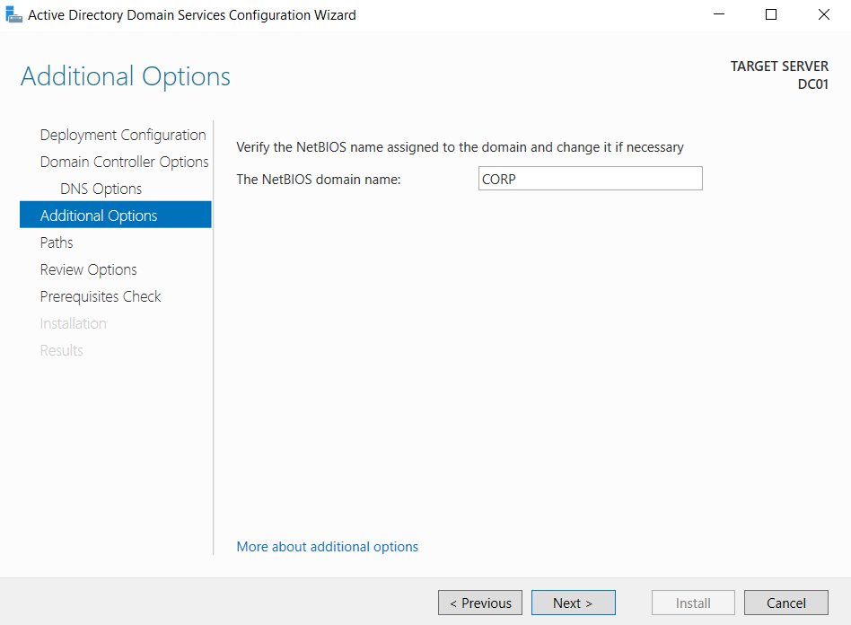

Step 5: Prerequisites & Installation
Successfully passed all prerequisite checks, confirming the server environment (OS patch level, Administrator password) was compliant before finalizing the installation.
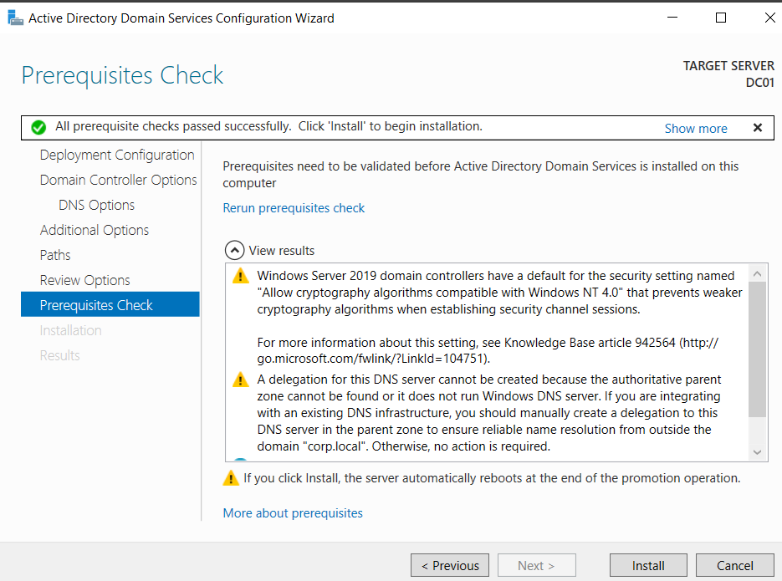

Step 6: Verification & Tools
After the restart, the Server Manager Dashboard confirmed that AD DS and DNS services are active (green).
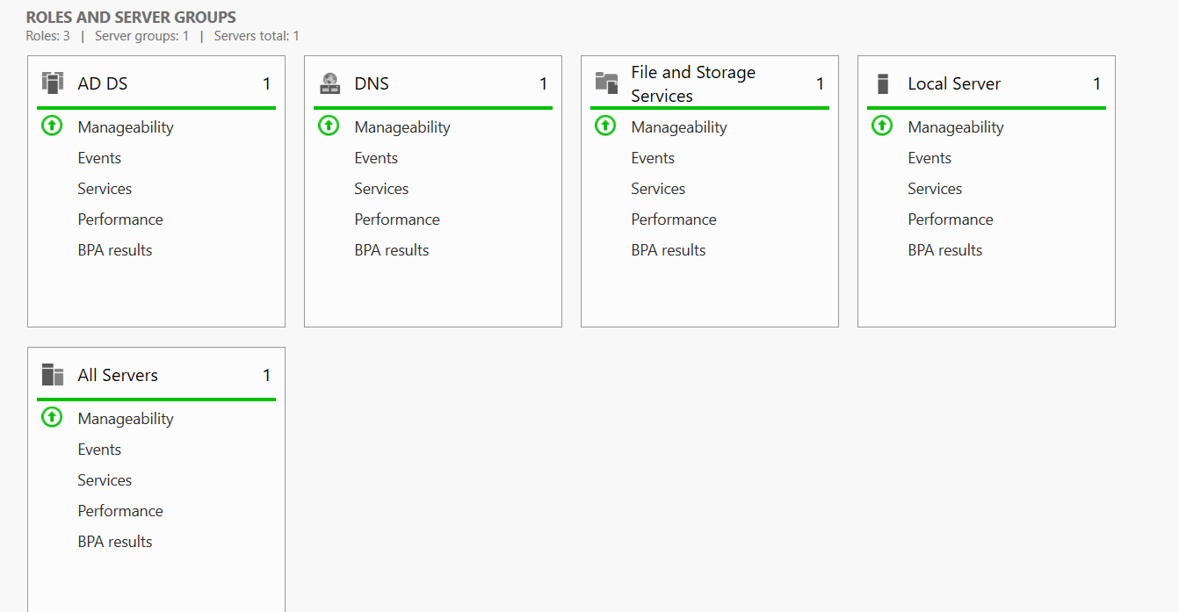
I also verified that the administrative tools, including “Active Directory Users and Computers”, were successfully installed and ready for user management.

Final Outcome
The server is now fully operational as the Primary Domain Controller for the `corp.local` domain. I have successfully:
1. Configured the Network Layer (Static IP).
2. Deployed the Identity Layer (AD DS).
3. Validated the Management Layer (AD Tools).

